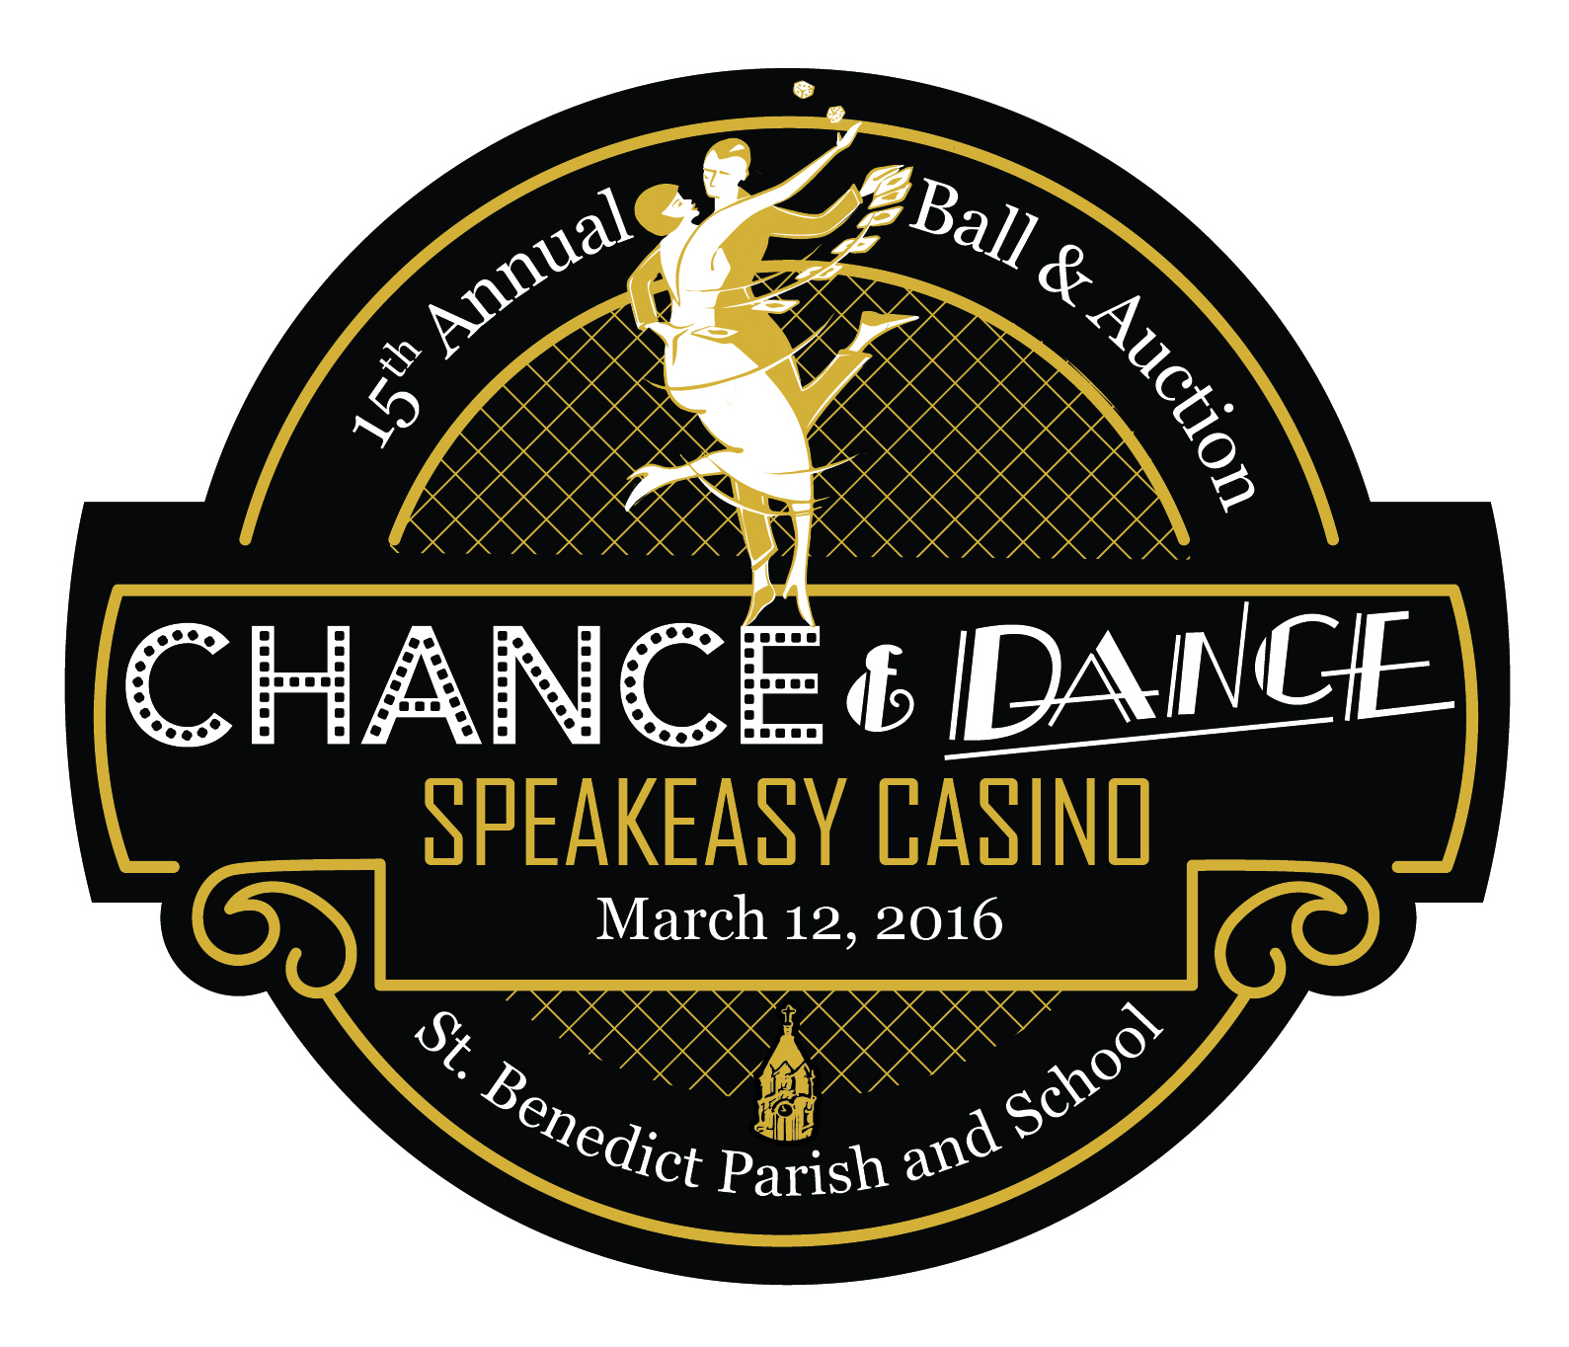
St. Benedict “Chance & Dance” Sponsorship Form
Ball & Auction Date: March 12, 2016

Event Sponsor Level (please check one):

- Rat Pack- $10,000
- High Roller- $5,000
- Lady Luck-$2,000
- Wise Guy-$1,000
- Wheel & Deal-$500

AUCTION BOOK SPONSOR—Place your ad in our 15th Annual Ball & Auction Program Book

___ $250 Full Page Ad (image size 5x8) ___ $175 Half Page Ad (image size 5x4)

___ $100 Quarter Page Ad (image size 2.5x4)

Please provide artwork/graphics. For message only, please use the back of this page.

Contact Information (please print)
Contact Name: ______________________________________________________________________________
Company Name: ____________________________________________________________________________
Address: _____________________________________________________________________________________
City, State, Zip: ______________________________________________________________________________
Contact Phone: ____________________________ Email: _________________________________________

Tell us how you would like your Logo/Name listed on all program material for the Ball & Auction. If you have a Company Logo to be used, please email it to cparry@stbenedict.com. ________________________________________________________________________________________________________________________________________________________________________________________________________________

Please submit this form by January 15, 2016 with your check made payable to St. Benedict Preparatory School to the address listed below. Thank you for your support!! SBPS is a 501c3 and donations are tax deductible. For more information regarding sponsorship levels, please contact Tricia Boguslawski tricia_bogus@yahoo.com or 773-849-3482.
